SIMATS ENGINEERING (SAVEETHA SCHOOL OF ENGINEERING)
Department of Artificial Intelligence and Data Science
ASSESSMENT TOOL 1 – APPLICATION BASED QUESTIONS

Course Code: | DSA03 | Course Title: | Natural Language Processing
CO Assessed: | CO1 – Imitation (L1) | Assessment: | Assessment Tool 1 – Application Based Questions
Weightage: | 40% of CIA
CO1 Statement: | Analyse NLP models, regular expression patterns, finite state automata, morphological processing techniques and to interpret language processing. (BL-3)
Student Name: | Y Greeshma Reddy | Reg. No.: | 192424146
Section / Batch: | B Tech-AI &DS | Date: | 15-07-2026

Code of Conduct
I Y Greeshma Reddy (Name / Reg No) certify that this submission is my original work and that I have adhered to the guidelines specified for this assessment. I understand that any violation of academic integrity rules will result in disciplinary action.
Signature of the Student: _Y.Greeshma Reddy__

Instructions
- Develop a modular and efficient Python program that satisfies all the functional requirements specified in the problem statement.
- Demonstrate the correctness of the implementation using suitable test cases and justify the output obtained.
- Follow good programming practices, including meaningful variable names, proper code indentation, comments, and error handling wherever applicable.
- Duration: 30 minutes.

Section / Topic | Focus | Q Nos
Information Extraction | Regex-Based Information Extraction | 1
Pattern Matching | Regex Pattern Matching | 2
Regular Expression Patterns | Regex-Based Input Validation | 3

Annexure A – Application Based Questions

Section 1: Regular Expressions – Resume Information Extraction
- A multinational recruitment company receives thousands of resumes every day in text format. The HR department requires an automated system to extract candidate information for shortlisting.

Design and implement a Python-based resume information extraction system using Regular Expressions that performs the following tasks:

Extract the candidate's name.
Identify email addresses.
Extract mobile numbers.
Detect technical skills (Python, Java, SQL, Machine Learning, NLP).
Extract years of experience.
Generate a structured summary of the candidate's profile.
Display candidates who satisfy the minimum eligibility criteria (minimum 2 years of experience and Python skill).

Section 2: Regular Expressions – Product Search System
- An e-commerce company plans to enhance its product search engine to improve customer experience through flexible keyword matching.

Design and implement a Python-based product search system using Regular Expressions that performs the following tasks:

Search products using an exact keyword.
Perform prefix-based searches.
Perform suffix-based searches.
Search using partial keywords.
Perform case-insensitive searches.
Display all matching product names.
Generate a report showing the total number of matching products for each search.
Section 3: Regular Expressions – University Registration System
A university is developing an automated online registration portal to verify student information before course enrollment.

Design and implement a Python-based validation system using Regular Expressions that performs the following tasks:

Validate the student register number.
Validate the institutional email address.
Validate the course code.
Validate the semester information.
Validate the student's mobile number.
Display appropriate validation messages for each field.
Generate a final registration status report indicating whether the registration is successful.

Section 1: Resume Information Extraction System

Aim
To develop a Python program using Regular Expressions to extract candidate details from a resume, identify eligible candidates, and generate a structured summary.

Problem Understanding
A recruitment company receives resumes in text format. The system should automatically extract important information such as the candidate's name, email, mobile number, technical skills, and years of experience. It should also check whether the candidate has at least 2 years of experience and Python skill to determine eligibility.

Concept Used
- Python re (Regular Expressions) module
- re.search() – Finds the first matching pattern.
- re.findall() – Finds all occurrences of a pattern.
- Pattern matching using regular expressions.
- Conditional statements (if).

Algorithm
- Import the re module.
- Read the resume text.
- Extract the candidate's name using a regular expression.
- Extract email addresses.
- Extract mobile numbers.
- Detect technical skills (Python, Java, SQL, Machine Learning, NLP).
- Extract years of experience.
- Generate and display the candidate summary.
- Check whether the candidate has Python skill and at least 2 years of experience.
- Display the eligibility status.
Sample Input
import re
resume = """
Name: Greeshma Reddy
Email: greeshma123@gmail.com
Mobile: 9876543210
Skills: Python, SQL, Machine Learning, NLP
Experience: 3 years
"""

# Extract Name
name = re.search(r"Name:\s*(.*)", resume)
name = name.group(1) if name else "Not Found"

# Extract Email
emails = re.findall(r"[A-Za-z0-9._%+-]+@[A-Za-z0-9.-]+\.[A-Za-z]{2,}", resume)

# Extract Mobile Number
mobile = re.findall(r"\b[6-9]\d{9}\b", resume)

# Detect Skills
skill_list = ["Python", "Java", "SQL", "Machine Learning", "NLP"]
skills = []

for skill in skill_list:
if re.search(skill, resume, re.IGNORECASE):
skills.append(skill)

# Extract Experience
exp = re.search(r"(\d+)\s+years?", resume, re.IGNORECASE)
experience = int(exp.group(1)) if exp else 0

# Display Summary
print("------ Candidate Summary ------")
print("Name:", name)
print("Email:", emails)
print("Mobile:", mobile)
print("Skills:", skills)
print("Experience:", experience, "Years")

# Eligibility
print("\n------ Eligibility ------")
if experience >= 2 and "Python" in skills:
print("Candidate is Eligible")
else:
print("Candidate is Not Eligible")
Sample Output
------ Candidate Summary ------
Name: Greeshma Reddy
Email: ['greeshma123@gmail.com']
Mobile: ['9876543210']
Skills: ['Python', 'SQL', 'Machine Learning', 'NLP']
Experience: 3 Years

------ Eligibility ------
Candidate is Eligible
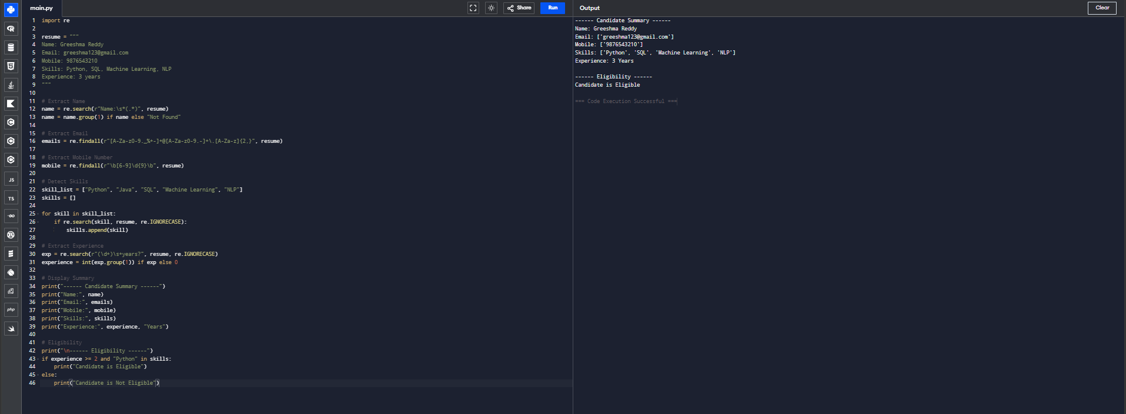
Result / Conclusion
The Python program successfully extracts the candidate's name, email address, mobile number, technical skills, and years of experience using Regular Expressions. It generates a structured candidate profile and correctly identifies candidates who meet the minimum eligibility criteria of at least 2 years of experience and Python skill.

Section 2: Product Search System

Aim
To develop a Python-based product search system using Regular Expressions that supports multiple search techniques and generates a search report.

Problem Understanding
An e-commerce company wants customers to search products easily using exact words, prefixes, suffixes, partial words, and case-insensitive searches. The system should display all matching products and count the number of matches for each search type.

Concept Used
- Python re module
- re.fullmatch() – Exact matching.
- re.match() – Prefix matching.
- re.search() – Suffix and partial matching.
- Case-insensitive matching using re.IGNORECASE.
- Lists and loops.

Algorithm
- Import the re module.
- Store the product names in a list.
- Accept the search keyword from the user.
- Perform an exact search using re.fullmatch().
- Perform a prefix search using re.match().
- Perform a suffix search using re.search().
- Perform a partial keyword search.
- Display all matching products.
- Count the number of matches for each search type.
- Display the search report.
Sample Input
import re
products = [
"Laptop",
"Laptop Bag",
"Mouse",
"Keyboard",
"Gaming Laptop",
"Phone",
"Phone Case",
"Smart Watch",
"Bluetooth Speaker",
"USB Cable"
]

# User Input
keyword = input("Enter Search Keyword: ")

# Exact Search
exact = [p for p in products if re.fullmatch(keyword, p, re.IGNORECASE)]

# Prefix Search
prefix = [p for p in products if re.match(keyword, p, re.IGNORECASE)]

# Suffix Search
suffix = [p for p in products if re.search(keyword + r"$", p, re.IGNORECASE)]

# Partial Search
partial = [p for p in products if re.search(keyword, p, re.IGNORECASE)]

# Display Results
print("\nExact Match:", exact)
print("Prefix Match:", prefix)
print("Suffix Match:", suffix)
print("Partial Match:", partial)

# Report
print("\n------ Search Report ------")
print("Exact Matches:", len(exact))
print("Prefix Matches:", len(prefix))
print("Suffix Matches:", len(suffix))
print("Partial Matches:", len(partial))

Sample Output
Exact Match: ['Laptop']
Prefix Match: ['Laptop', 'Laptop Bag']
Suffix Match: ['Laptop', 'Gaming Laptop']
Partial Match: ['Laptop', 'Laptop Bag', 'Gaming Laptop']

------ Search Report ------
Exact Matches: 1
Prefix Matches: 2
Suffix Matches: 2
Partial Matches: 3
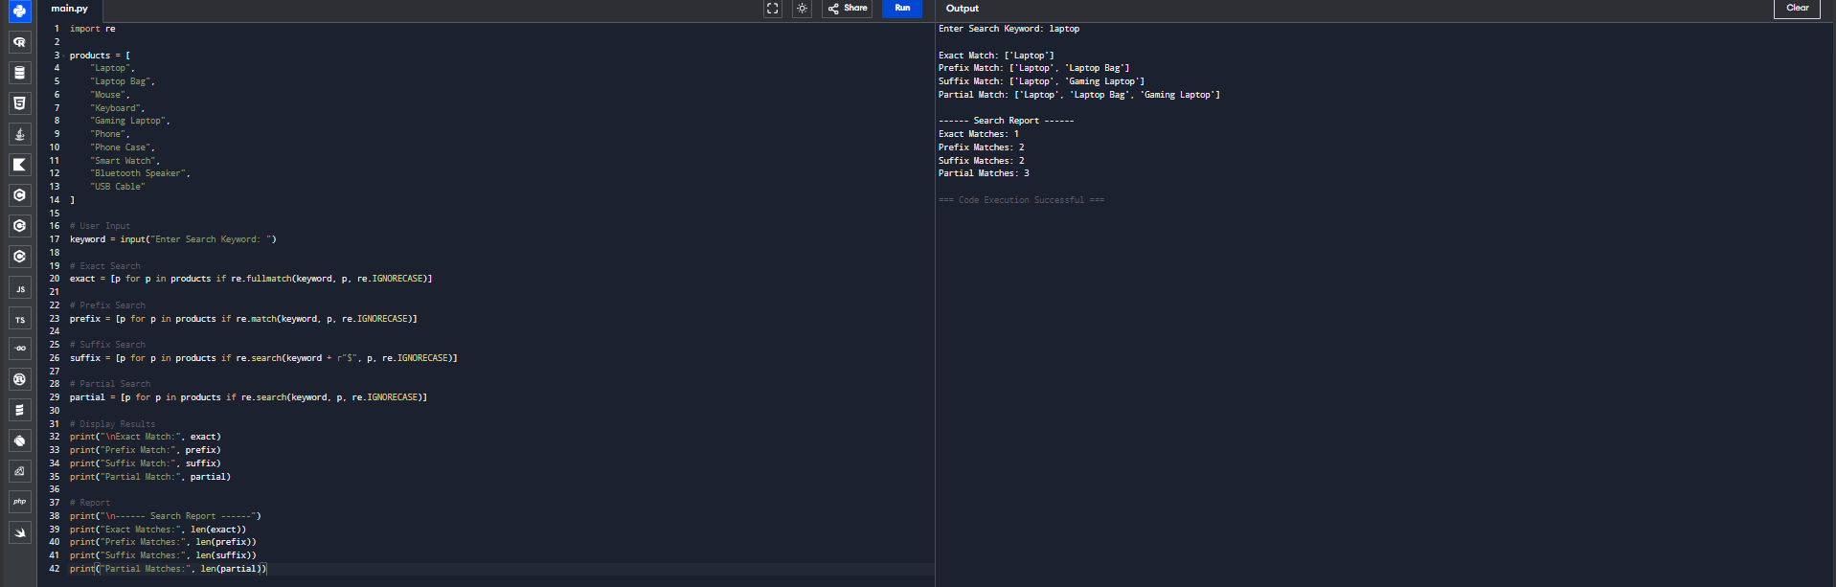

Result / Conclusion

The Python program successfully performs exact, prefix, suffix, partial, and case-insensitive product searches using Regular Expressions. It displays all matching product names and generates a report showing the total number of matches for each type of search, improving the efficiency of product searching.

Section 3: University Registration Validation System

Aim
To develop a Python program using Regular Expressions to validate student registration details and generate a registration status report.

Problem Understanding
A university registration portal should verify student details before allowing course enrollment. The system validates the register number, institutional email, course code, semester, and mobile number. Registration is successful only if all details are valid.

Concept Used
- Python re module
- re.fullmatch()
- Regular Expressions (Regex)
- Conditional Statements
- Boolean Variable

Algorithm
- Import the re module.
- Accept the register number.
- Accept the institutional email.
- Accept the course code.
- Accept the semester number.
- Accept the mobile number.
- Validate each field using regular expressions.
- Display validation messages.
- Check whether all fields are valid.
- Display the final registration status.

Sample Input

import re

reg_no = input("Enter Register Number: ")

email = input("Enter Institutional Email: ")

course = input("Enter Course Code: ")

semester = input("Enter Semester: ")

mobile = input("Enter Mobile Number: ")

status = True

# Register Number

if re.fullmatch(r"\d{2}[A-Z]{3}\d{4}", reg_no):

print("Register Number: Valid")

else:

print("Register Number: Invalid")

status = False

# Institutional Email

if re.fullmatch(r"[A-Za-z0-9._%+-]+@college\.edu", email):

print("Email: Valid")

else:

print("Email: Invalid")

status = False

# Course Code

if re.fullmatch(r"[A-Z]{2,4}\d{3}", course):

print("Course Code: Valid")

else:

print("Course Code: Invalid")

status = False

# Semester

if re.fullmatch(r"[1-8]", semester):

print("Semester: Valid")

else:

print("Semester: Invalid")

status = False

# Mobile Number

if re.fullmatch(r"[6-9]\d{9}", mobile):

print("Mobile Number: Valid")

else:

print("Mobile Number: Invalid")

status = False

# Final Status

print("\n------ Registration Report ------")

if status:

print("Registration Successful")

else:

print("Registration Failed")

Sample output

Register Number: Valid
Email: Valid
Course Code: Valid
Semester: Valid
Mobile Number: Valid

------ Registration Report ------
Registration Successful

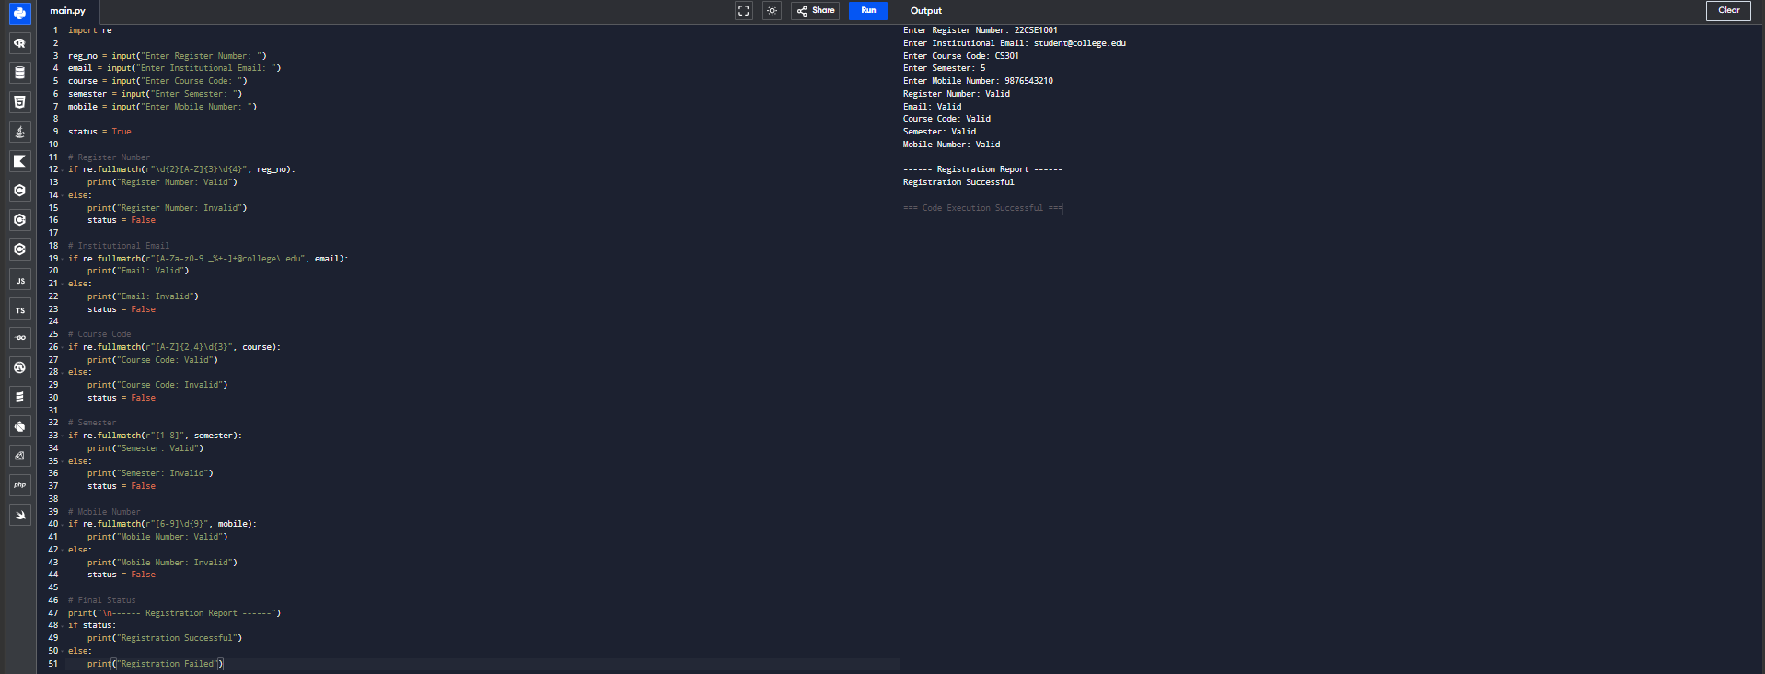

Result / Conclusion

The Python program successfully validates the student register number, institutional email, course code, semester, and mobile number using Regular Expressions. It displays appropriate validation messages for each field and generates a final registration status indicating whether the student's registration is successful or failed based on the validity of all entered details.

Rubrics for Calculation
Criteria | Weightage | Level 4 – Exemplary | Level 3 – Proficient | Level 2 – Developing | Level 1 – Beginning
Understanding of Problem Context | 20 | Clearly understands the problem and accurately identifies all requirements | Good understanding with minor gaps | Basic understanding; some requirements unclear | Poor understanding or misinterpretation of the problem
Application of Concepts | 30 | Accurately applies appropriate concepts to solve complex problems | Applies relevant concepts correctly with minor errors | Applies basic concepts with limited accuracy | Fails to apply appropriate concepts
Problem-Solving Approach | 20 | Logical, well-structured, and efficient approach | Mostly logical approach with minor gaps | Basic approach with some inconsistencies | Illogical or unclear approach
Accuracy of Solution | 20 | Completely correct solution with proper justification | Mostly correct with minor errors | Partially correct solution | Incorrect or incomplete solution
Clarity | 10 | Clear, well-organized, and properly explained solution | Understandable with minor clarity issues | Limited clarity and explanation | Poorly presented and difficult to understand

Q. No. / Criteria | Understanding of Problem Context | Application of Concepts | Problem-Solving Approach | Accuracy of Solution | Clarity | Sub. Total | Total %
1
2
3

Faculty In-charge | Course Coordinator | Program Director
Signature: _______________ | Signature: _______________ | Signature: _______________
Date: ___________________ | Date: ___________________ | Date: ___________________

